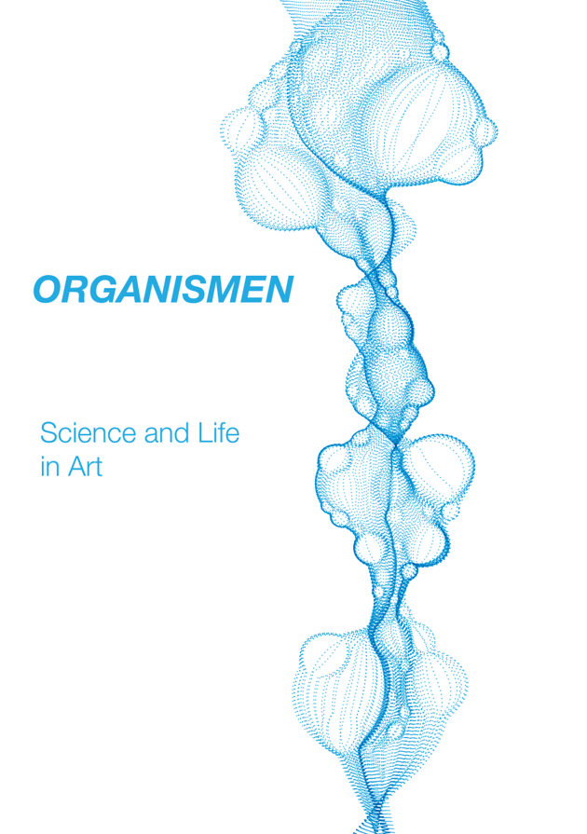

ORGANISMEN

Science and Life in Art

Organismen [‘Organisms’] is an exhibition adjacent to the 27th Annual Conference of the Friedrich Nietzsche Society, dedicated to the theme Science, Art, Life. Nietzsche (1844-1900) is one of the most influential philosophers of our modernity. While profoundly engaged with the meaning of human existence, his interests encompased the arts and the sciences of his day. One of his primary influences from the life sciences was Wilhelm Roux (1850-1924), a zoologist and early experimental embryologist. It was Roux’s first book, Der Kampf der Theile im Organismus [The Struggle of the Parts in the Organism] which had a profound affect on Nietzsche. While agreeing with much in Darwin’s theory of evolution, Nietzsche objected to the idea that what drives the formation of organisms is external pressures and influences (adaptation to environmental factors). Nietzsche found a corrective to Darwin in Roux’s work, which focuses on the inner struggle of organisms instead of the struggle between species.

According to Roux, an organism is not simple, but is composed of parts which compete for nutrition and space in their growth and functioning. This occurs at the level of cells, tissues, and organs. The organism is then a higher-functioning product of this inner struggle. Roux’s theory was a profound influence on the development of Nietzsche’s idea of the will to power. From the purely material, organic forms studied by the life sciences, Nietzsche expanded the idea to the metaphysical description of all reality: ‘This world is the will to power—and nothing besides! And you yourselves are also this will to power—and nothing besides!’ Nietzsche’s conception of life is focused on conflict, struggle, and the formation of the different parts of the organism into a heirarchy where some power-wills command and others obey. His vision was consciously opposed to the democratic models prevalent in the life sciences of his day. And yet, his mature view was not simply one of aristocracy and domination: in order to explain how one will could affect another will, he theorised that the ‘commanding’ will emits an impulse, which the ‘obeying’ will agrees to act on through its own autonomous agency. Moreover, the command structure of the organism is not necessarily stable, so commanding and commanded wills can and do change places. What Nietzsche might be understood to emphasise then is this: ‘The essential thing in the life process,’ he wrote, ‘is precisely the tremendous shaping power, creating form from within.’

Nietzsche’s philosophical methodology transposes structures from one phenomenon to another, seeing what is revealed in the sciences as having import for the arts, and vice versa. Beyond the literal scientific meaning, then, an artwork may be seen as an organism. Nietzsche applied organic theory to his art and cultural criticism, seeing succesful artworks as healthily functioning organisms, which have the effect of enhancing life and culture, and decadent art (his later view of Wagner) as a sick organism in which the organs have separated and cease properly to work together.

An art-organism is a functioning confluence of agonistic power-wills, in which colour, line, timbre, shape, texture, and a thousand other subtleties contend for perspectival dominance in the work, and – if the work is successful – result in a unique consort of surprising sensations. Generalised and simplified, this is the struggle of Apollo and Dionysus, of form and chaos, dream and intoxication, which together can produce great tragic, life-affirming art.

The artworks collected here each explore themes related to Nietzsche’s thought, or to the confluences of art, science, and life in broader ways. These art-organisms are unitary products of inner struggle, which stimulate and agitate the organisms of our own bodies and minds, a stimulus which can itself enhance life. As you approach they may look deceptively docile, sitting on the wall or floor like sleeping seals. But inside they seethe; they’ll let you catch a glimpse of the chaos of their becoming if you’re lucky, if you approach with an open soul. Let them antagonise and seduce you. Let them succour and renew you. Yes, these artworks are organisms; each one vibrates with life. Which ones will resonate with yours?

References

Gregory Moore, Nietzsche, Biology and Metaphor (Cambridge: Cambridge University Press, 2009).
Wolfgang Müller-Lauter, ‘The Organism as Inner Struggle: Wilhelm Roux’s Influence on Nietzsche’ in Nietzsche: His Philosophy of Contradictions and the Contradictions of His Philosophy, trans. David J. Parent (Urbana and Chicago: University of Illinois Press, 1999).
Wolfgang Müller-Lauter, ‘Artistische décadence als physiologische décadence. Zu Friedrich Nietzsches später Kritik an Richard Wagner’ [‘Artistic Decadence as Physiological Decadence. On Friedrich Nietzsche’s Later Critique of Richard Wagner] in Nietzsche-Interpretationen 2 (Berlin: Walter de Gruyter, 1999).
Friedrich Nietzsche, The Will to Power, trans. Walter Kaufmann and R.J. Hollingdale (New York: Vintage, 1968), §1066.
Wilhelm Roux, Der Kampf der Theile im Organismus (1881)

A. Woodward

Symbiote

Irene Aldazabal and Angela Gillies

Symbiote is a collaboration between Angela Gillies and Irene Aldazabal, in which they bring together their backgrounds in Arts, Sciences and Humanities. This work reflects on Soil and Earth as the place where we belong, where cycles of life and decay happen constantly. In Symbiote, the materials sourced from the earth have come together in symbiosis, mutually beneficial to each other. The varied sizes of the objects inside the box invite the audience to notice more-than-human others that, even if many times unseen, are vital and sustain multispecies life processes. The way in which the objects are shown is inspired by sciences and natural museums, while at the same time has an artistic imprint that creates a dialogue between the elements, highlighting the ecology of livable relations on Earth.

Irene Aldazabal is a student in the MFA Art and Humanities, and Angela Gillies is a student in the MFA Art, Science and Visual Thinking, DJCAD, University of Dundee.

Cyborg Goddess

Morgan Black

The work reflects my ongoing practice as a comix artist and illustrator whose work focuses on challenging the heteronormative in popular media and society. As a nonbinary researcher, I am committed to embracing the potential which technology and science can offer the individual to expand concepts of being, selfhood, gender and experience. Notions of trans-humanism and Nietzsche's theories of overcoming the human are what inform this piece. Recreation of the self, for me personally, was possible only through my long-term interfacing with science in the form of the Internet which allowed me to evolve my inner selves via the use of avatars, text and video chat, to become embodied, lived personae in reality - an evolution of the self which allowed a revolution in my own artistic practice.

A version of this piece also features in the artist’s recent cyberpunk short film Hardwired, a fusion of art, science and self, which is planned to be screened at a one-off event at DJCAD in late October 2022.

Morgan Black is a PhD candidate in Fine Art, DJCAD, University of Dundee.

Tidal Durations

Zac Caspersen

This triptych film documents the washing away of paintings made during Zac’s MFA in Art & Humanities at DJCAD (2022) that use sand and tempera paint mixed together on mdf panels. The paintings prior to this washing were a means to represent actions resulting from meditation and leaving chance to occur based on how the medium reacts. My work has connections to the void, the unconscious, and discovering a new understanding of the inner self. This performance highlights Nietzsche’s theory on how objects, temporality, and consciousness are in a constant flux. There is no end point or final stage, even if objects are seemingly stagnant in their place. Due to the use of the natural material, sand, the washing away can allude to climate disasters from floods causing runoff and landslides in addition to topography and land.

Zac Caspersen is a student in the MFA Art and Humanities, DJCAD, University of Dundee.

Memento Mori

Caroline Erolin

I am a medical artist by day, who makes work exploring the natural world, especially concepts around life and death in my own time. This piece ‘Memento Mori' has particular personal significance as it an etching of my now deceased cat Finnegan. A portrait capturing him in both life and death. However, it is also scientifically accurate, being based on his actual skull (he was a Maine coon, so they have particularly large and robust skulls!).

Etching is a process that involves covering a metal plate in a thin ground and scratching the line work of the image into this. The plate is then emersed traditionally in acid, but in my case I use the less dangerous alternative of copper sulphate, in order to etch the line into the metal. 'Aquatinting' is the process of adding areas of tone. As this is a zinc plate, a spray aquatint is applied over the line etch to give a texture that can then be further etched in the copper sulphate.

Caroline Erolin is a Senior Lecturer in the Centre for Anatomy and Human Identification, University of Dundee. She runs the MSc in Medical Art (a joint programme between DJCAD and CAHID).

Subject and Object
Paola McClure and Alan Richardson
Skeletal forms stand in the contrasting environments of enclosed and exposed environments, seemingly aware of forces about to be enacted on them, inflicted either by chance or by the choice of others. This work relates to the Nietzschean concept of amor fati, in its depiction of entities that appear to be accepting fate, whether awaiting subjugation to deliberate actions under controlled conditions or thrown open to the unpredictable nature of the elements.
This work is part of an ongoing collaborative project between sculptor Paola McClure and photographer Alan Richardson. McClure and Richardson’s collaborative works have been shown at the SSA annual exhibition and in exhibitions across the UK and in Northern Ireland.
Paola McClure completed the MFA in Art & Humanities at DJCAD in 2018 and was an Artist in Residence at the college in 2019.
@paolamcclurevisualart
paola_mcclure@yahoo.co.uk

Alan Richardson is an award-winning freelance photographer working for national newspaper and magazines as well as private, business and PR clients.

Asunder

Katie Hart Potapoff

Asunder is a meditation on the moment when a singular intention is split in two. Each decision, wish, prayer, question - captured in bronze casts, began in wax, carefully rolled between palms into small balls. As each was grasped between two sets of thumb and forefinger, an intention was brought into focus, and the ball torn asunder. 12 sets were sent into the pour, only 10 emerged - pairings forged anew. This iterative artistic process echoes the act of wrestling with philosophical ideas: to test, weigh, and reconsider.
Katie Hart Potapoff is a PhD candidate at DJCAD, University of Dundee.
www.katiehartpotapoff.com

Skin by Skin: saucer
Louise Ritchie
The soft fleshy velvet and laser-engraved pattern of Skin by Skin: saucer, signifies the experiences and thin transitions between childhood, adulthood and womanhood. The motif is a pattern, borrowed from a family heirloom, an old saucer; an emotive object, once used to cradle its spousal cup. Here, as an image, it exists as a temporal aide-memoire, an evocation of a life in time and flux. Life through art, art through life.
In this piece, past lives are explored through an engraved motif that acts as an illusionary lens, a kaleidoscope of memory. The sumptuous velvet is sliced through with lasers but form a delicate pattern on and below the surface to connote indexical incisions of experience and recollection; recollections as indelible inscriptions - and scars - of triumph and sorrow. The skins of the moment, the skins of then, and the skins of loss, all leave their trace as material time-markers to settle, year upon year, in a loose gathering of experience and celebration, loss and renewal.
Louise Ritchie is a PhD candidate at DJCAD, University of Dundee.

@louiseritchiegram

Rachna

Samiksha Yeole

After being in the field of science for almost 10 years, I decided to try to look at science from a different perspective, that of art. Stars and other celestial phenomenon have always fascinated me. I’ve enjoyed reading about the constellations, galaxies and space. But I had not until recently noticed the similarities shared by life sciences and astronomy. Through my present work I am learning to explore these commonalities and create visuals. These prints are inspired by the recognition that the process of star formation in space and cell division in the human body are visually similar. I used the thought of cell division happening in space, with all the surrounding physical forces and elements needed for star formation aiding the process. The patterns are the supporting elements which help in the formation of the stars and cell division, and they keep changing at each stage of division. The colours are the stains we use to see cell division under a microscope.
Rachna, meaning creation in Sanskrit, is a research project which focuses on how the small unnoticed things in our surroundings are significant in the process of creation. The comparison between cell division and star formation made me realise that all things need these elements to exist and multiply. The patterns in these prints signify those elements and continue to change with every stage of division.
Samiksha Yeole is a student in the MFA in Art, Science and Visual Thinking, DJCAD, University of Dundee.

